CURRICULUM VITAE ( fill with your own info )

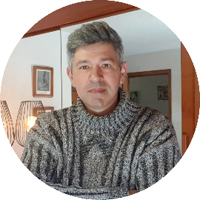 |  |  | ( I am a 53 years old Sociologist and Art Teacher from Lisboa, Portugal )
 |  |  | EXPERIENCE
( Your image )

Francisco Capelo  ( Whattsapp: 351 - 96 584 88 43 )  franciscocapelo@gmail.com  QUOTE  “we all are artists” – Joseph Beuys |  |  | .  .  .  .
 |  |  | QUALIFICATIONS
.
.
.
.
 |  |  | CAPABILITIES
DRIVER´S LICENSE  - Yes/ No |  |  | .  .
 |  |  | WRITTEN BOOKS
INTERESTS
Visual Arts |  |  | .  .  .
LANGUAGES
 |  |  | REFERENCES
English

www.4RT.pt

